**Assignment**

**Q.1 Find out the mail servers of the following domain**

Nslookup

Set type=mx

[www.ibm.com](http://www.ibm.com)

[www.wipro.com](http://www.wipro.com)

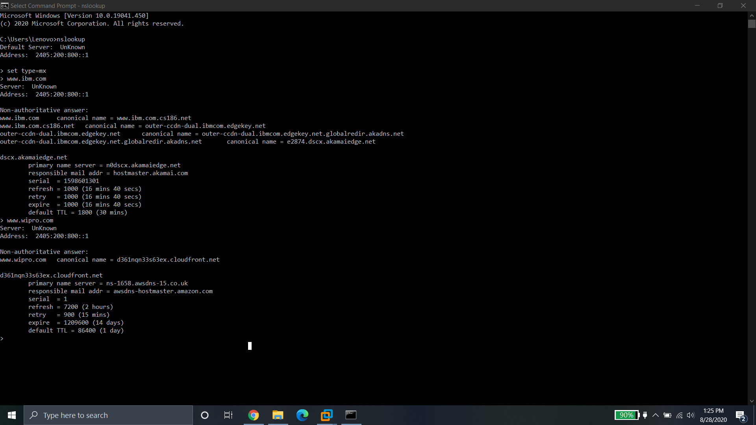

**Q.2 Find the locations, where these email servers are hosted.**

Currently the site is not working. So unable to download email tracker pro.

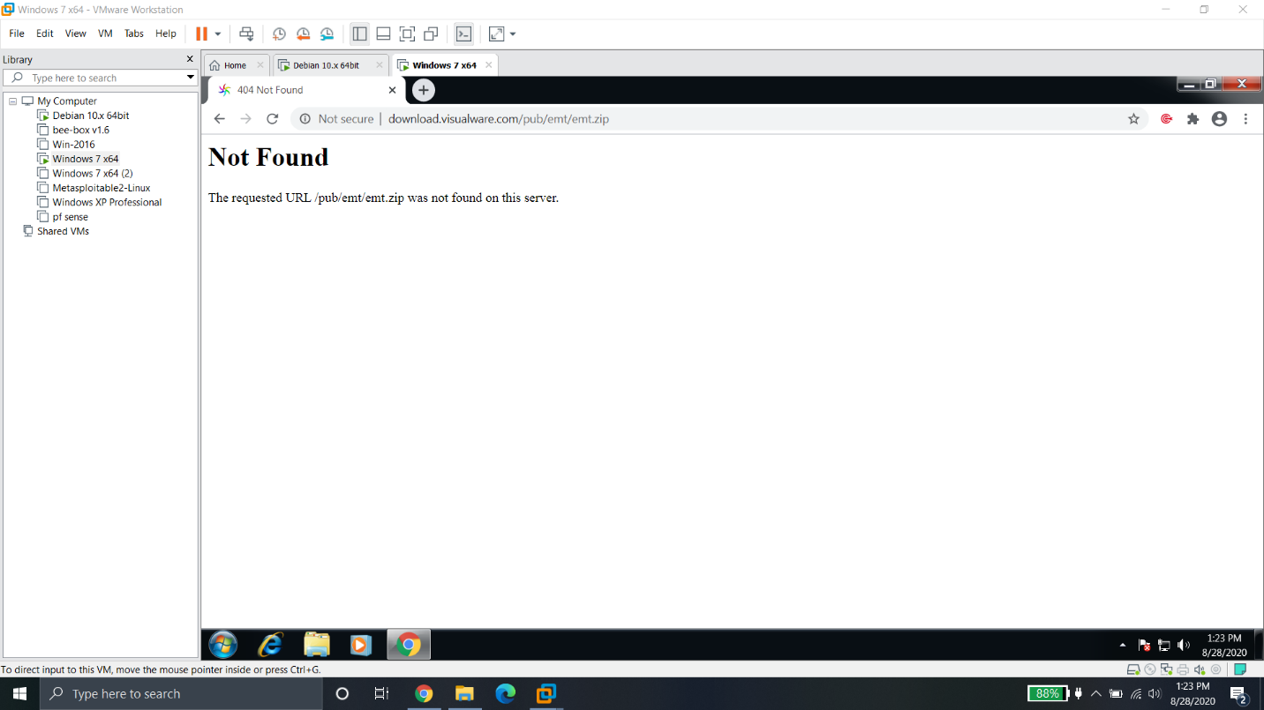

**Q.3 Scan and find out port numbers open 203.163.246.23**

Nmap -p1-65535 203.163.246.23

All 65535 ports are filtered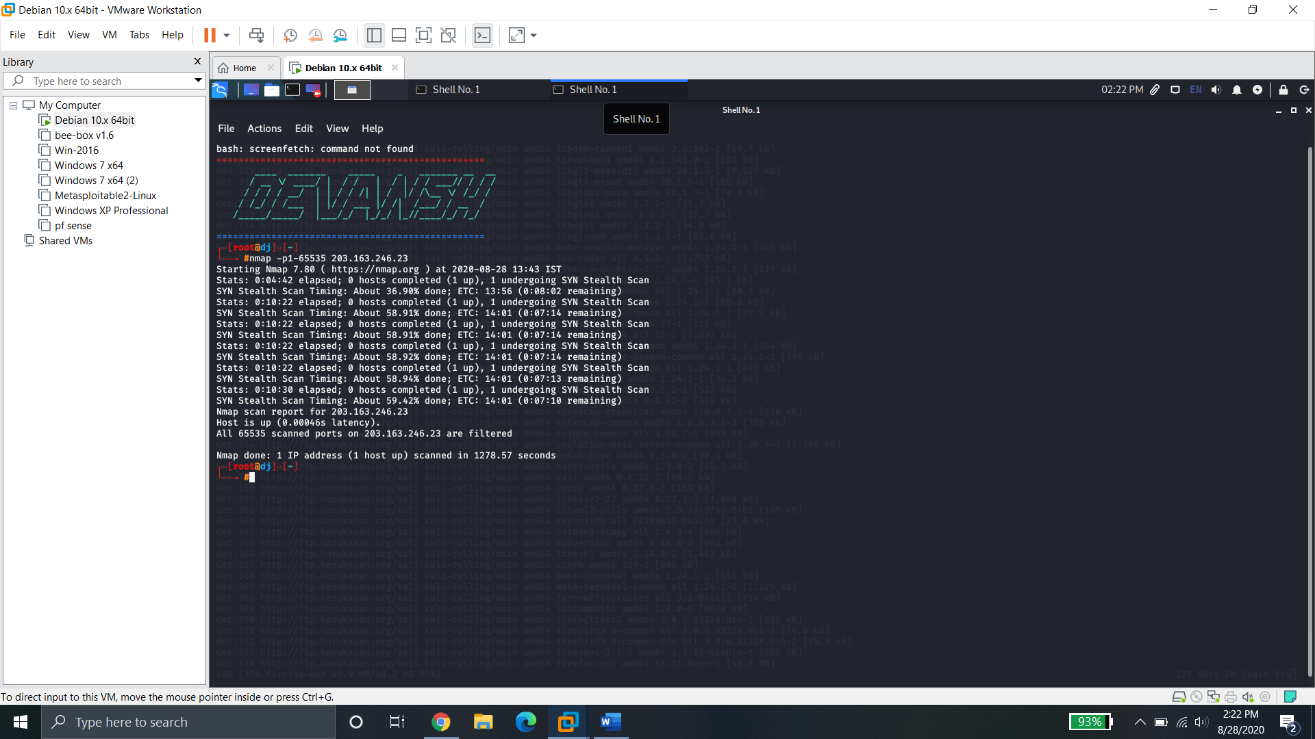

**Q.4 Install nessus in a VM and scan your laptop/desktop for CVE.**

